EDHP588
Name: Yu-Ting Hung
Professor: Dr. Gena Burgess
Date: March /11/2009

Lesson Plan 5

Topic | Chinese Moon Festival |  |  |  | Students | 3rd grade | Number |  | 20
Instructors | Yu-Ting Hung (Christine) |  |  |  | Time | 45mins
Description of class |  |  |  | - Setting: Elementary School 3rd Grad, ESL setting  - Linguistic backgrounds: Spanish and English
Goals |  |  |  | The main purpose of the lesson is to expose students to the Chinese Moon Festival. After this lesson, students will learn its history and importance to Chinese culture.
Learning Objectives |  |  |  | Terminal Objective:  Students will be able to describe what activities people can do on Chinese Moon Festival.  Enabling Objectives:  1. Students will be able to answer the questions about the origin of Dragon Boat Festival  2. Students will be able to retell the story of Chinese Moon Festival on the worksheet.  3. Students will be able to plan their own Chinese Moon Festival.
Materials & Equipment |  |  |  | Blackboard, Power point, and worksheets.
Procedure |  |  | Demonstration |  |  |  |  | Time
- Presentation  - Guided Practice  - Independent Practice |  |  | Motivation  Today, We are going to be learning about the Chinese Moon Festival and why it is an important cultural holiday in Taiwan.  Chinese Moon Festival is on the full moon day of mid-autumn. It's an occasion for family reunion. Chinese families like to get together to eat the moon cakes and watch the moon at the Moon Festival night.  Activity I: Introducing Chinese Moon Festival  - The teacher introduces what Taiwanese do on Moon festival. Teacher uses power point to introduce activities.  - We watch the full moon.  Traditional Food eaten during the Moon Festival-  - We eat moon cakes.  Moon Cake Symbolizes:  - The yolk symbolizes the moon.  - Moon Cakes are round like the moon.  - The circle (shape of the Moon Cake) is a symbol of harmony.  - The round shape also stands for family unity  - The round shape symbolizes the cycle of life  - Connects the past, present, and future  - Long life and good health  - We can eat pomelos (Chinese Grapefruit). The sweet fruit is believed to scare off evil and it has a round shape.  - We can use pomelo’s peels to make hats.  - We have barbecue party.  - We listen to the story of Moon Festival.  Activity II: The stories of Moon Festival  - Lady Chang Er (Appendix A)  - Wu Gang, the moon’s woodcutter (Appendix B)  Activity I: What can we do on Chinese Moon Festival?  - Students are required to retell the story of Lady Chang Er on the worksheet (Appendix D).  Activity II: What do you plan to do on Moon Festival?  Students are required to plan their own Chinese Moon Festival (Appendix C). |  |  |  |  | 5’  10’  10’  10’  10’
Evaluation |  |  | - Students will be evaluated by answering the questions the teacher asks.  - Students will be evaluated by the worksheet.
Reference |  | Childbook (n. d). Retrieved March, 7, 2009 from http://www.childbook.com/Chinese-Moon-Festival-and-Autumn-Background-s/141.htm  Mdnkids (n. d) Retrieved March, 7, 2009 from http://www.mdnkids.com/fall/catelog.htm  Chidbook (n. d) Retrieved March, 7, 2009 from http://www.childbook.com/Chinese-Moon-Festival-Teaching-Lesson-Plans-Worksheets-s/298.htm  EzineArticles (n. d) Retrieved March, 7, 2009 from http://EzineArticles.com/?expert=Ray_Ritchey

Appendix A

The story of the beginning of this important holiday dates back to 2000 B.C. An old legend says that there were originally ten suns and each one took turns appearing in the sky. One day all ten suns appeared in the sky at once and the heat was too much for everyone on Earth.
A strong, brave young man at the time was Ho-Yih. He was a great archer. Ho-Yih shot nine of the suns out of the sky. He became a hero and the king rewarded him with a magic pill that gave him eternal life. He secretly hid the pill under the pillow of his wife, Chung-O.
One day Chung-O discovered the magic pill and swallowed it! Ho-Yih was angry, but the pill allowed Chung-O to fly up into the sky, all the way to the moon. Ho-Yih tried to pull her down but there was nothing he could do to stop her. Now she lives on the moon and Ho-Yih can visit her one day every year, the same day that we celebrate Moon Festival. Now, people gather together for Moon Festival, eat moon cakes and admire Chung-O’s beauty.

Appendix B
Another legend is of Wu Gang, the smart but lazy Moon's Woodcutter. One day he decided that he wanted to be an immortal. Wu Gang then went to live in the mountains where he met an old immortal to teach him. First the immortal taught him about the herbs used to cure sickness, but after three days he became impatient and he asked the immortal to teach him something else. So the immortal taught him chess, but after a short while Wu Gang was get tired. Then Wu Kang was given the books of immortality to study. Of course, Wu Kang became bored within a few days, and asked if they could travel to some new and exciting place. The master was angry about Wu Gang's impatience; the he sent Wu Kang to the Moon Palace telling him that he must cut down a huge cassia tree before he could return to earth. He tries again and again to cut down the Moon's tree of immortality, which just magically heals after every chop. He was sentenced to this by the Jade Emperor for selfishly seeking the elixir of immortality, and thus he is up there chopping still.

Appendix C
What do you plan to do on Moon Festival?
I plan to __________ on Moon Festival.
There are many things you can do on Moon Festival. What would do plan to do on Moon Festival? Who will you plan to invite? Write down your plan and share with your friends.

_____________________________________________________________________________________________________________________________________________________________________________________________________________________________________________________________________________________________________________________________________________________________________________________________________________________________________________________________________________________________________________________________________________________________________________________________________________________________________________

Appendix D
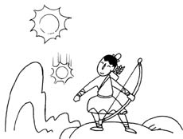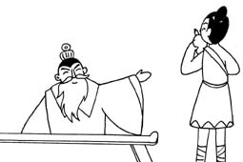

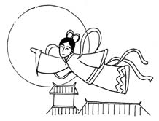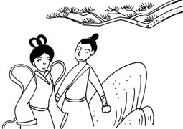

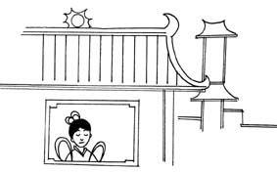

Name: Date:
5.

